**How to use QRadioButton - An Example**

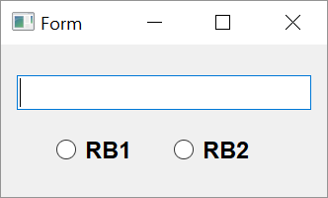

**Step 1**

Adding the widgets to the form

1. Place a QLineEdit box, two radio button objects and two horizontal spacers in horizontal layout on the form and apply vertical layout to parent window.
2. Name the text box as t1 and radio buttons as rb1 and rb2.
3. Set checkable property of both radio buttons to true from property editor window.
4. Save this form as rbtn.ui and obtain its Python script by using conversion utility pyuic5.

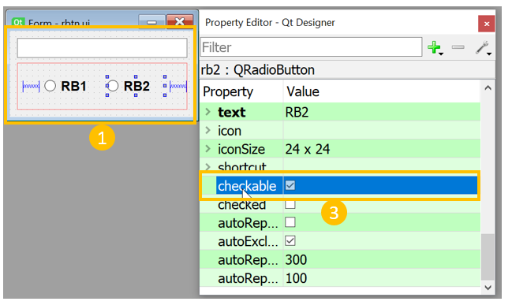

**Step 2**

**Event Handling**

1. Open the rbtn.py file. QRadioButton widget emits toggled signal. Connect this signal to following event handler method.

**def checkstate(self):**

**state1='OFF'**

**state2='OFF'**

**if self.rb1.isChecked()==True:**

**state1='ON'**

**else:**

**state1='OFF'**

**if self.rb2.isChecked()==True:**

**state2='ON'**

**else:**

**state2='OFF'**

**self.t1.setText("Button1 is {} Button2 is {}".format(state1,state2))**

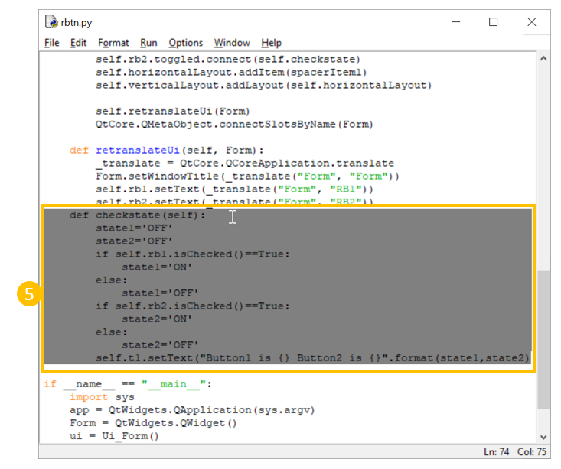

1. Following statements connect this method to radio buttons.

**self.rb1.toggled.connect(self.checkstate)**

**self.rb2.toggled.connect(self.checkstate)**

